**JAVASCRIPT BASIC & DOM**

• What is JavaScript?

**Ans:-** JavaScript is a programming language that used for creating interactive and dynamic content on websites.

• What is the use of isNaN function?

**Ans:-** The isNan function in JavaScript is primarily used to check whether a value is “Not a Number”(NaN) or not. It returns ‘true’ if the value is NaN and ‘false’ if it’s a valid number or can be coerced into one. Its often employed for input validation or when dealing with calculations where the result might not be a number.

• What is negative Infinity?

**Ans:-** Negative Infinity is a special value in JavaScript representing the mathematical concept of negative infinity. It is a value that is similar than any other numeric value, including negative numbers. In JavaScript, it’s denoted by the constant ‘Number.NEGATIVE_INFINITY’.

• Which company developed JavaScript?

**Ans:-** JavaScript was developed by Netscape Communications Corporation, specifically by Brendan Eich in 1995. At the time, it was originally named Mocha, then briefly LiveScript, before finally being renamed JavaScript.

• What are undeclared and undefined variables?

**Ans:-** Undeclared variables are not declared with ‘var’, ‘let’, or ‘const’, resulting in a reference error and undefined variables are declared but not assigned a value, so they return undefined when accessed.

• Write the code for adding new elements dynamically?

**Ans:-** 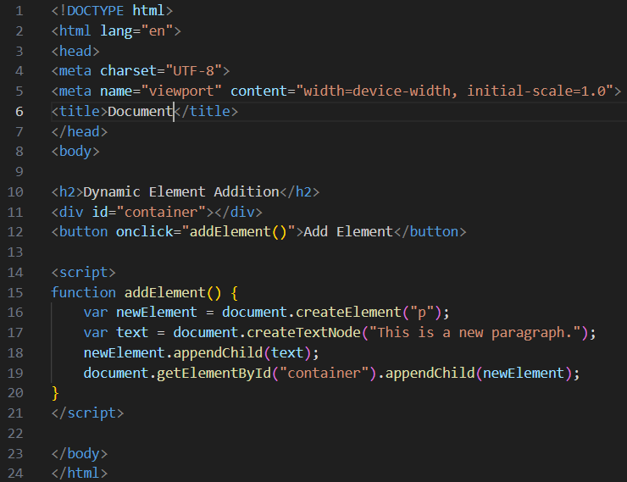

• What is the difference between ViewState and SessionState?

**Ans:-** ViewState stores the state of controls on a single web page across postbacks, while SessionState stores user-specific data across multiple pages during a session.

• What is === operator?

**Ans:-** The ‘===’ operator is a strict equality operator in JavaScript. It compares two values for equality without performing type conversion. In other words, it checks if the value are not only equal in value but also of the same type.

• How can the style/class of an element be changed?

**Ans:-** You can change the style of an element using JavaScript by directly modifying its ‘style’ property or by manipulating its ‘className’ property to add, remove, or replace classes.

• How to read and write a file using JavaScript?

**Ans:-** In a web browsers, JavaScript can read files indirectly through file input elements or the FileReader API. Writing files directly form the browsers is restricted, but you can generate downloadable files using data URLs or Blob objects.

• What are all the looping structures in JavaScript?

**Ans:-**

1. For loop statement.

2. Do…while loop statement.

3. While statement.

4. Continue statement.

5. Break statement

• How can you convert the string of any base to an integer in JavaScript?

**Ans:-** In JavaScript, you can use the ‘parseInt()’ function to convert a string representation of a number in any base to an integer. The ‘parseInt()’ function takes two arguments: the string to be parsed and the base of the numeral system in which the number is represented.

• What is the function of the delete operator?

**Ans:-** The ‘delete’ operator in JavaScript is used to remove properties from objects or elements from arrays.

• What are all the types of Pop up boxes available in JavaScript?

**Ans:-** In JavaScript, there are three types of popup boxes, Alert Box, Confirm Box and Prompt Box which are often used to interact with users and gather input or provide information in web applications.

• What is the use of Void (0)?

**Ans:-** The use of ‘void(0)’ in JavaScript is typically to prevent the browser from taking any action when an anchor (‘<a>’) element is clicked without navigating to a new page.

• How can a page be forced to load another page in JavaScript?

**Ans:-** In JavaScript, you can force a page to load another page by setting ‘window.location.href’ to the URL of the new page.

• What are the disadvantages of using innerHTML in JavaScript?

**Ans:-** Using ‘innerHTML’ in JavaScript can lead to security vulnerabilities, performance overhead, loss of event handlers, less semantic markup, inability to execute inserted scripts and loss of element state.